The Sacramento Chinese Golf Club and the Federation of Chinese Golf Clubs
Cordially invite you to participate in the

59TH BIENNUAL
MEMORIAL DAY TOURNAMENT
May 23 - 25, 2014

GOLF THE HIGH SIERRA and ELDORADO HOTEL & CASINO
have put together a wonderful and memorable golf package for us to enjoy.

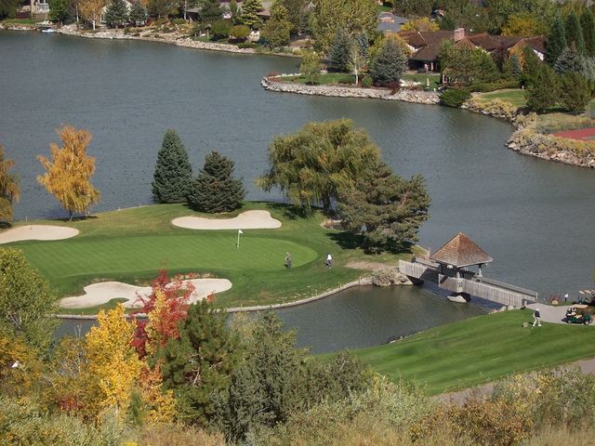

We start our Memorial Day Event on Friday at LakeRidge Golf Course. This Robert Trent Sr. course has been voted "Best of Reno" year after year. Hole #15 is a world famous par 3 set atop a rocky ridge
140 feet above Lake Stanley to an island green.

SHAMBLE TEAM Event. Shotgun start at 1:30pm
(Carts and range balls will be provided)

This will be a team format, random pairings. We will be playing a shamble: everyone tees off, team chooses the best drive, and everyone plays their own ball in from there. Lowest 2 net scores counts as team score. On the scorecard, note which player drove the ball as there is a 3 tee ball requirement / player (so strategize accordingly).
Immediately after golf, we have our FEDERATION WELCOME PARTY
at the Eldorado Hotel and Casino.

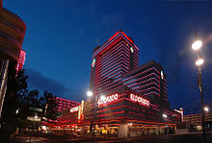

The PARTY will start at 8:00pm. Hosted cocktails and hors d'oeuvres
(Antipasto Platter, Caesar Salad, Fruit Platter, Roasted Rosemary Chicken, Mushroom Ravioli, Tortellini Eldorado,
Uncle Willie's Meat Ravioli, Assorted Rolls and Cheese Straws)
will be served from 8:00pm - 9:00pm ( ***cash bar after 9:00pm)
Karaoke and Dancing from 8:00pm - 11:30pm

You can "SLEEP IN" after a night of food, drinks, fun and gambling... We will golf at Award Winning Robert Trent Jr. Red Hawk Hills Golf Course.

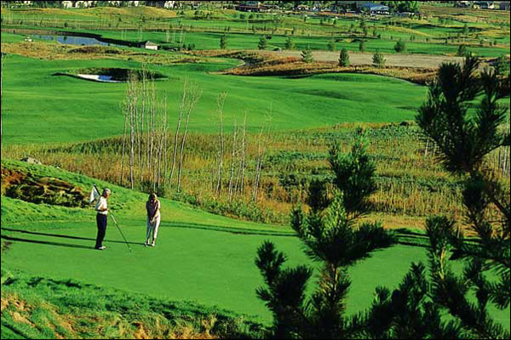

36 HOLE MEDAL PLAY – DAY 1 MEDAL PLAY
Saturday shotgun start at 1:30pm
(Carts and range balls will be provided)
SATURDAY NIGHT IS ON YOUR OWN

Round 2 will be played at Award Winning Robert Trent Jr.
Red Hawk Lakes Golf Course.

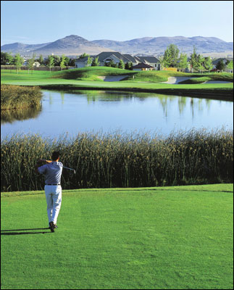

36 HOLE MEDAL PLAY – DAY 2 MEDAL PLAY
Sunday shotgun start at 8:30am
(Carts and range balls will be provided)

The FEDERATION AWARDS DINNER will be held at the
Eldorado Hotel and Casino

Hosted cocktails will be provided between
5:00pm and 6:00pm ( ***cash bar after 6:00pm)

Plated Prime Rib 3-course dinner will start at 5:00pm
(Please advise if you have special dietary needs)
HOSPITALITY SUITE

Open Friday and Saturday nights till midnight (closed during events)
HOSTED COCKTAILS (until we run out...)

PLEASE DRINK RESPONSIBLY

THURSDAY, MAY 22, 2014 - PRACTICE ROUND

Voted Best Golf Course in Northern Nevada in 2011, Somerset Golf & Country Club, designed by Tom Kite, features 62 white sand bunkers,
400-foot wide landing areas, dramatic elevation changes
and spectacular mountain views

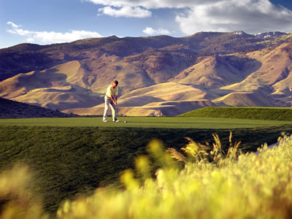
2019 Championship Trail
Reno, Nevada 89523
(775) 787-1800

$70 PER PLAYER AT 11:00AM
$60 PER PLAYER AFTER 1:00PM

COSTS

3 rounds of GOLF, MEALS & HOSPITALITY ONLY (no accommodations)

$379 / golfer $_________

The room packages listed below are for the Eldorado Hotel and Casino includes the 13.5% room
tax and $10/night resort fee. Each golfer will also receive a sleeve of premium golf balls,
Eldorado Logo Golf Hat, Eldorado Fun Book valued at over $75, Club Eldorado Players Card
and one complimentary drink coupon good at Brew Brothers or Roxy's.

STAYING FRIDAY AND SATURDAY NIGHTS

2 nights 3 rounds in hotel room (shared room) - $549 / golfer $_________
Name of roommate: ____________________________

2 nights 3 rounds (golfer and non-golfer) - $839 / couple
Name of Non-Golfer: ____________________________ $_________

2 nights 3 rounds in hotel room (single room) - $729 / single $_________

STAYING FRIDAY, SATURDAY AND SUNDAY NIGHTS

3 nights 3 rounds in hotel room (shared room) - $629 / golfer
Name of roommate: ____________________________ $_________

3 nights 3 rounds (golfer and non-golfer) - $999 / couple
Name of Non-Golfer: ____________________________ $_________

3 nights 3 rounds in hotel room (single room) - $899 / single $_________

GUEST FEE (Meals and Hospitality only)

$110 per guest (if not staying on a package above) $_________

ADDITIONAL NIGHTS AT THE EL DORADO

Early arrival on Thursday 5/22/14 - $79/room (includes tax and resort fee) $_________

THURSDAY, MAY 22, 2013 PRACTICE ROUND AT SOMERSET

$70 per player between 11:00am - 1:00pm $_________

$60 per player after 1:00pm $_________

TOTAL $_________

132 MAXIMUM GOLFERS - DEADLINE TO ENTER MAY 2, 2014 - NO REFUNDS AFTER MAY 2, 2014
ENTRY FORM (one form per player)

NAME
ADDRESS
CITY
STATE/PROVINCE
PHONE
E-MAIL

GHIN NUMBER or RCGA NUMBER or
ASSOCIATION and PLAYER NUMBER
Verifiable handicap required to qualify for prizes
CLUB AFFILIATION

MAXIMUM NCGA HANDICAPED INDEX: MEN - 36 WOMEN - 40
------------------------------------------------------------------------------------------------------------------------------------

PAY VIA CREDIT CARD - Register by calling GOLF THE HIGH SIERRA 1-(877)-332-4465. Advise which package you will be selecting, give your name and the name of roommate or non-golfing roommate (if you have one), and leave your credit card information to reserve your spot. At the time of reservation, a deposit of $100 will be taken and applied towards the final balance due 30 days prior to tournament date. The final balance will be charged to your credit card. E-Mail this Entry Form and Costs Sheet to Rocky (ryee_yjk@comcast.net), so that he can confirm reservations and do the pairings.

PAY VIA CHECK - Or mail your golf and/or hotel registration, Entry Form, Costs Sheet and check to: Golf the High Sierra, 1325 Airmotive Way #130, Reno, NV 89502.
Family and Friends are always welcome to play.

ROOMS ARE LIMITED (only 50 reserved). BOOK NOW!!!

EARLY ENTRY DRAWING
(***must book a golf & room package above to qualify )

Sign up prior to February 1, 2014 and get 2 raffle tickets ***
Sign up between February 1 to March 1, 2014 and get 1 raffle ticket ***

RENO VACATION PACKAGE - HOTEL & GOLF FOR 2
Two nights room and tax at the Eldorado Hotel Casino in Reno, One round of golf for two at LakeRidge Golf Club,
One round of golf for two at Wolf Run Golf Club, Good 7 days week, must be booked 7 days in advance.
Subject to availability, not good on holidays or special event periods. $500 value!

